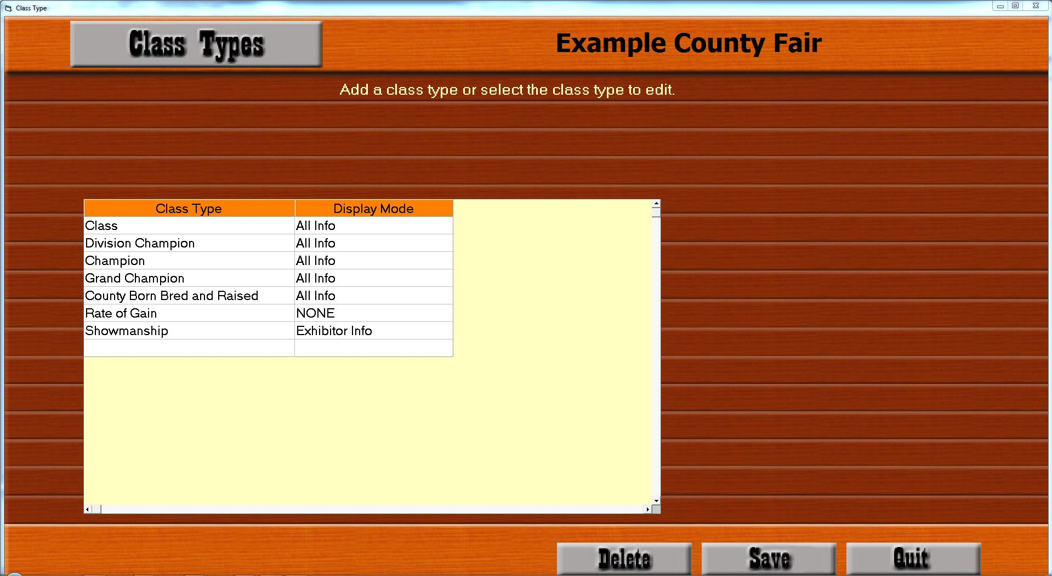

* These example class types can be created as defaults when you first open the screen from the setup menu. The first step is to determine which Class Types will be needed. Email GrandChampions@sspro.com for assistance with this process.
* Class Type : This is a description column that can be named anything. It is recommended to leave ‘Class’ at the top because that is the most accessed Class Type. Any of these can be renamed at any time without causing any issues.
* Display Mode : This controls how the classes within this class type are displayed on the show bill. The options are ‘All Info’, ‘Exhibitor Info’, and ‘NONE’. Use ‘All Info’ for normal classes. Use ‘Exhibitor Info’ for those class types that should not need to show lot information. Use ‘NONE’ for class types that should have all information hidden on the show bill.

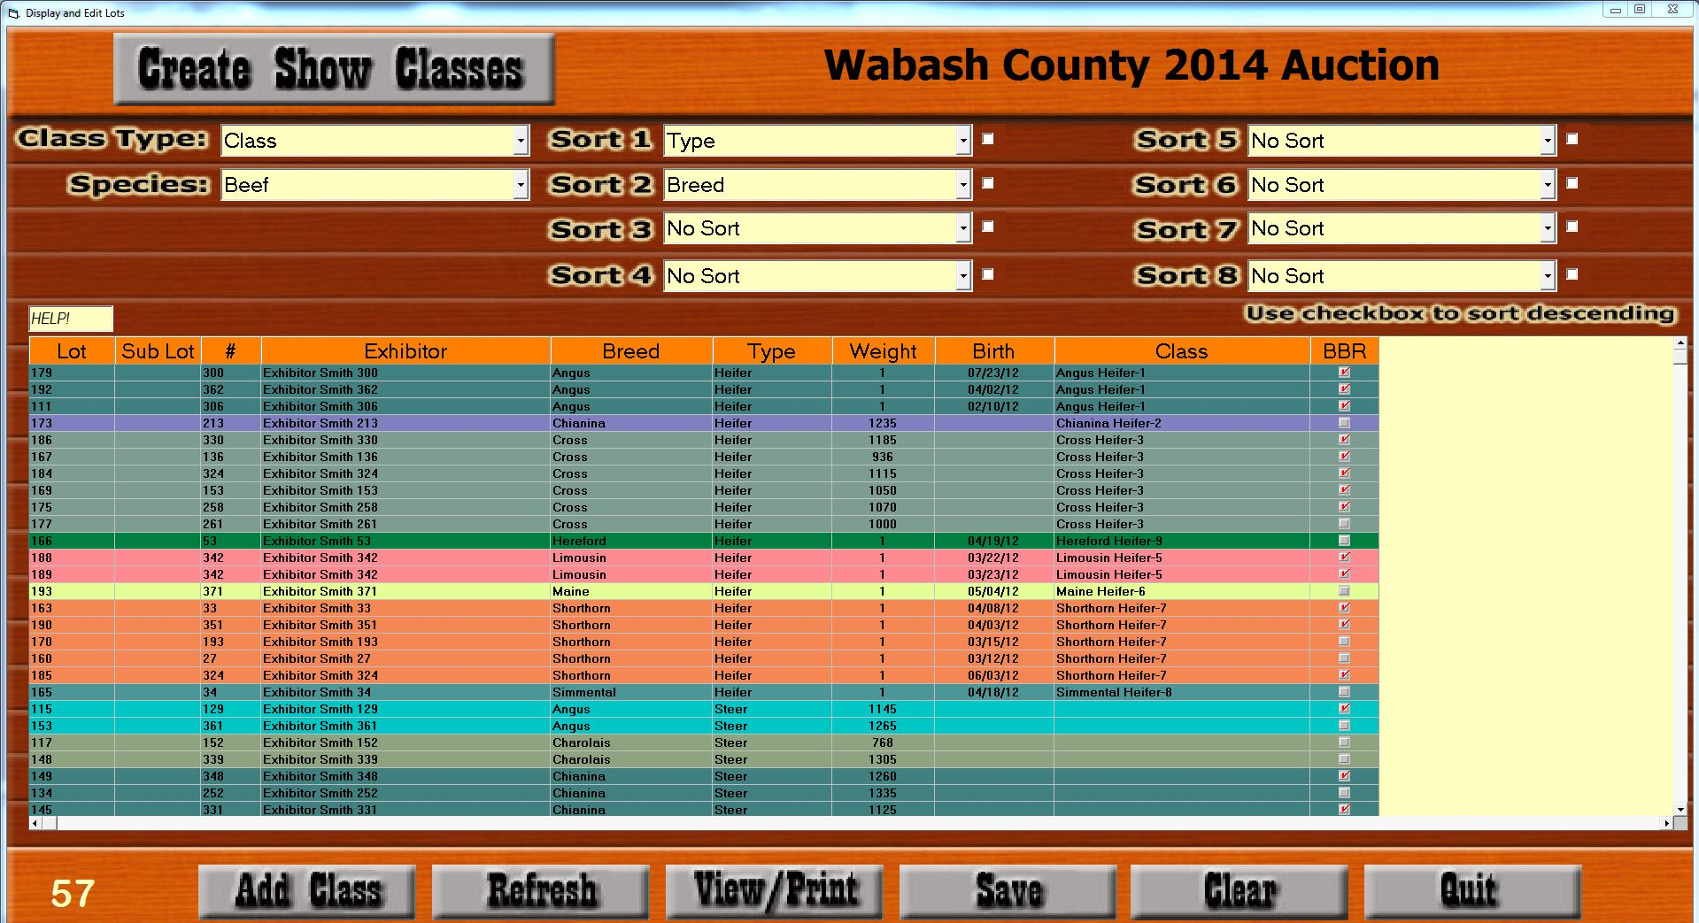

* The Create Show Classes screen will allow you to assign large quantities of animals to classes. If that class already exists, the class column dropdown can be clicked to find and select that class. Otherwise, selecting “New Class” in that same dropdown, then keying CTRL or CTRL+ENTER will open up the Add/Edit Classes screen where you can modify the class you are creating, or hit CTRL+ENTER to select default attributes.

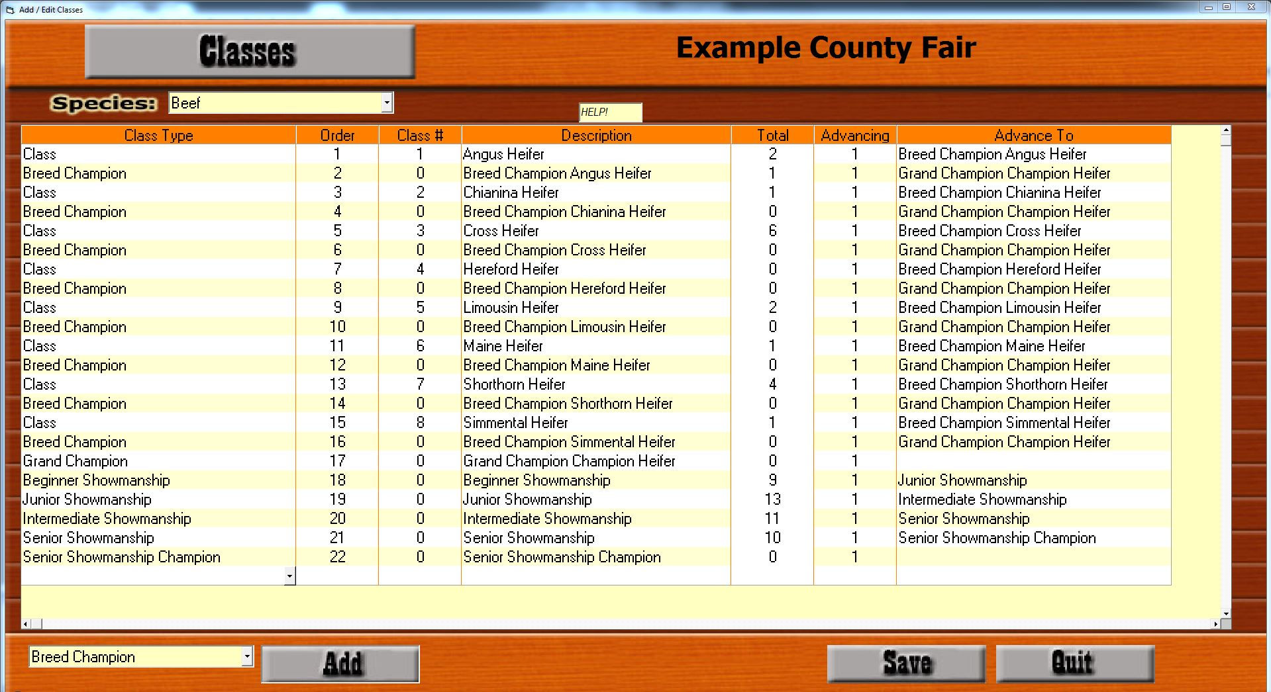

* **Purpose :** The Add/Edit Classes screen is the screen used to control progression of the show.
* **Class Type :** The purpose for various class types is seen on this screen when a “Class” class type can advance to a “Breed Champion” class type. Then, the “Breed Champion” class type can advance to the “Grand Champion” class type. Reminder: A class should never advance lots/exhibitors to another class of the same class type.
* **Order :** You can set the number in the order column to automatically move a class to a different position in the show. The order is not displayed anywhere outside of this screen. It simply controls the order of the show.
* **Class # :** Some classes can be assigned a class number; the rest will be set to “0”. If a non-zero class number is entered, it will display on the show bill along with the description.
* **Description :** Each class can be assigned a description that will show up on the show bill. The description is also helpful when adding animals to that class from the Create Show Classes screen.
* **Total :** This column shows you how many lots/exhibitors have already been assigned to this class and cannot be edited. For example, the “Breed Champion” class will have 0 lots assigned until the placings have been entered for the “Class” classes, which will happen during the show.
* **Advancing :** The Advancing column controls how many animals advance to the next level. This column will default to 1, but can be modified. The number of animals advancing from the “Cross Heifer” class to the “Breed Champion Cross Heifer” class is set to 1 in this example, because only the first place winner will advance. (NOTE: Second-place runner-up advancement for evaluation of the Reserve Breed Champion is handled on the Placings screen)
* **Advance To :** The Advance To column controls where the winner(s) advances to. In this example, “Cross Heifer” is advancing 1 animal to “Breed Champion Cross Heifer”. This column is a dropdown which contains all saved classes. Being careful to save after adding each class will ensure that the class you wish to advance to is in the dropdown and can be assigned.
* **Add :** The Add button at the bottom of the screen is designed for quickly adding Division, Breed, Grand Champion, etc classes to the show. Clicking the Add button will add a default class of the selected Class Type under the active row.

*For example*, in order to add a “Breed Champion” class called ‘Breed Champion Cross Heifer’ under the last class for Cross Heifers, the user would select the last Cross Heifer class in the list (clicking anywhere in that row will make it the active row), select the “Breed Champion” class type in the dropdown at the bottom of the screen, and click the Add button. The new class will populate a new row under the active row. Verify that the description is correct and click Save.

*Recommendation…*For the sake of efficiency, it is highly recommended that all “Class” classes be added prior to adding Breed Champions, etc to the show.

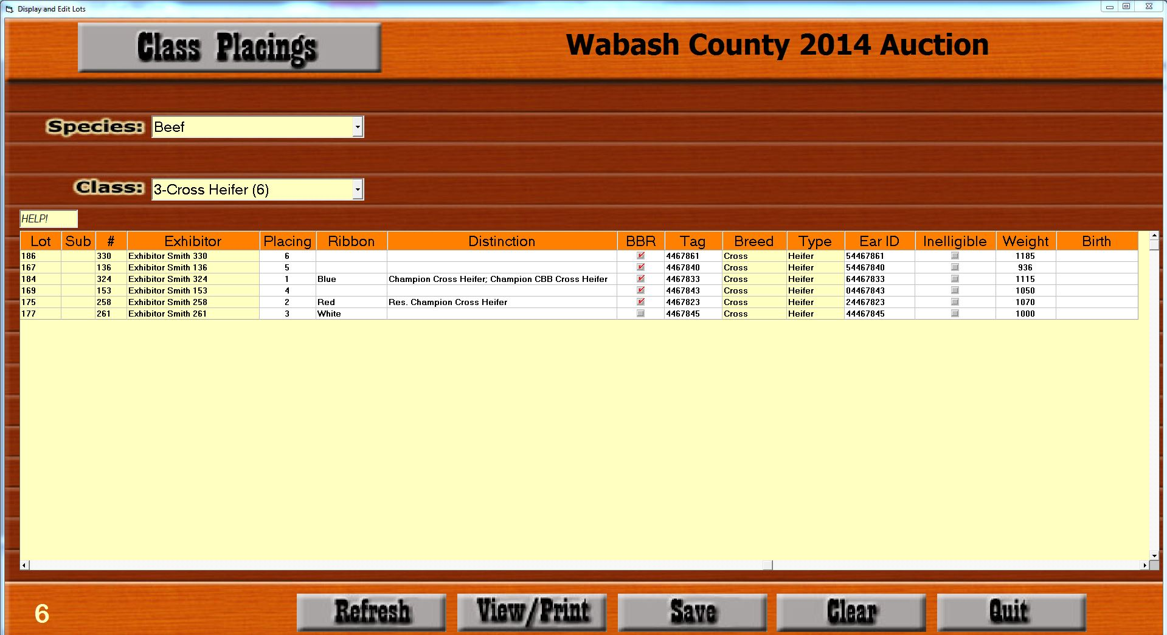

* Enter placings, ribbons, and distinctions on the Placings screen. Once this screen is saved, the number of configured advancing animals will be added to the Advance To class setup in the Add/Edit Class screen.
* **Placing :** After recording the first place animal, the program will check for second-place runner-ups. If one exists, the user will be given the option to advance this lot/exhibitor to the current class for consideration of second place.
* **Ribbon :** The ribbon will print on the Simple Show Report after the show which can be provided to the Extension office.
* **Distinction :** Right-click the Distinction column for access to the list of default distinctions. Distinction may also be edited on this screen (without right-clicking).